Name of Student | Class/Session | Area of achievement | Date/Month/Year | Position/Rank | Photos
1. SHIRSHA ROY | X C | National Level : 1ST POSITION IN VOCAL TRADITIONAL FOLK CATEGORY(FEMALE) | December 2021 | Regional 1ST POSITION IN VOCAL TRADITIONAL FOLK CATEGORY(FEMALE) - Selected for Nationals | 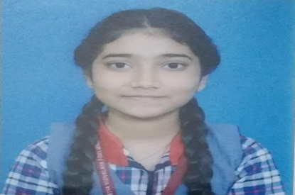
2. Debargha Chakraborty | VIII A | KVS-NVS national solo patriotic song competition -4TH POSITION | September 2021 | KVS-NVS national solo patriotic song competition -4TH POSITION
3. Arkodeep sen | 10D | 1. Kala Utsav Cluster level, 1st Position(3D sculpture) | October 2021 | 1. Kala Utsav Cluster level, 1st Position(3D sculpture)
4. Swapnil dutta | 9 B | Kala Utsav Cluster level, 1st(Toy/Game) | October 2021 | Kala Utsav Cluster level, 1st(Toy/Game)
5. Tiyasha Den | 7 | NCSC National Level: Project-Ecosystem for sustainable living | November 2021 | NCSC Project Selection for National Level
6. Saptarishi Majumdar | X | Inspire Award : Selection for making Working Model | December 2021
7.Rishika Sahu | IX B | Inspire Award : Selection for making Working Model | December 2021
8.Kanishka | XI | NTSE Scholarship | 29/10/2021 | NTSE Scholarship
9. Abhishek Kumar Mahato | XII , SC,2020-21 | 1. IIST 2021 , ALL INDIA RANK - 34  2. JEE Advance 2021 : OBC NCL rank 320 , AIR- 2143 | October 2021 | 1. IIST 2021 , ALL INDIA RANK - 34  2. JEE Advance 2021 : OBC NCL rank 320 , AIR 2143 | 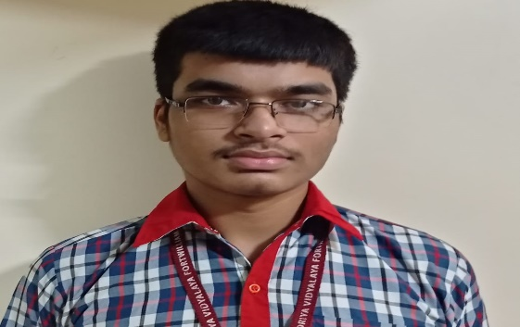
10. Anamitra Das | XII , SC,2020-21 | 1. JEE Advance 2021- ALL INDIA RANK : 27737 SC Category Rank 950 , Got Admission at IIT Delhi | October 2021 | 1. JEE Advance 2021- ALL INDIA RANK : 27737 SC Category Rank 950 , Got Admission at IIT Delhi
11.Ahana Pal | XII C , 2020-21 | 1.NEET 2021 ,All India Rank 1789 | October 2021 | 1.NEET 2021 ,All India Rank 1789

