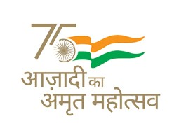
Kendriya Vidyalaya Sangathan (HQ)
New Delhi
Extension Notice for Admission: 2022-23

Subject: -Extension of last date of Online Registration for Class- I Fresh Admission for the Academic Session 2022-23

Madam/ Sir,

The last date for Online Registration for Admission to Class I in Kendriya Vidyalayas for the Academic Year 2022-23 has been further extended from 11.04.2022 to 13.04.2022 (Wednesday) . Accordingly, the Online Registration, which has commenced on 28.02.2022, will now close on 13.04.2022.

By Order.

